Weather Image Classification

Khushali Malaviya1, Shivang Modi2

1[cb.en.p2cse22005@cb.students.amrita.edu](mailto:2cb.en.p2cse22005@cb.students.amrita.edu)

2[cb.en.p2aie22007@cb.students.amrita.edu](mailto:3cb.en.p2cse22008@cb.students.amrita.edu)

*School of Computing, Amrita Vishwa Vidyapeetham  
Coimbatore, India*

***Abstract*—*The aim of this project is to classify images of different weather conditions using machine learning techniques. The dataset used for training and testing the model will consist of images of various weather conditions such as, cloudy, rainy, foggy, sunset and shine . The model will be trained using a variety of machine learning algorithms and the performance will be evaluated based on metrics such as accuracy, precision, and recall. The goal is to give a comparison study between different feature extraction and classification algorithms to accurately classify images of different weather conditions.***

***Keywords***— ***Machine Learning; Image Classification; Logistic regression; SVM; Clustering; Feature selection; Decision trees; Classification; XG-Boost; MLP;***

1. Introduction

In the industrial world, weather classification is very useful, such as in the development of self-driving cars, smart transportation systems, and outdoor vision systems. Time and again unfortunate accidents due to inclement weather conditions across the globe have surfaced. Plane crashes, ship collisions, train derailments, and car accidents are some of the tragic incidents that have been a part of headlines in recent times. This grave problem of safety and security in adverse conditions has drawn society’s attention.

Numerous studies have been done in the past to expose the vulnerability of the functioning of transportation services due to weather conditions. With the advancement in technology and the emergence of a new field, intelligent transportation, and automated determination of weather conditions have become more relevant. Therefore weather conditions are an important factor that is considered for various decisions. Manual weather classification by humans is inconsistent and takes a long time.

The goals of weather image classification using a machine learning model can vary depending on the specific application, but some common goals include:

1. *Weather prediction:* The model can be trained to predict the weather for a given location and time based on the features of the weather image, such as cloud cover and precipitation.
2. *Severe weather detection:* The model can be trained to detect severe weather conditions, such as tornadoes and thunderstorms, in order to provide early warnings to the public.
3. *Cloud classification:* The model can be trained to identify different types of clouds and their characteristics, such as height and thickness, which can provide important information for weather forecasting and climate research.
4. *Precipitation estimation:* The model can be trained to estimate the amount and type of precipitation, such as rain or snow, from weather images, which can provide important information for agriculture and disaster management.
5. *Identifying weather patterns:* The model can be trained to identify patterns in weather images over time and extract information about long-term climate patterns, which can be used in research and forecasting.
6. *Real-time monitoring*: The model can be trained to continuously monitor weather images in real-time and provide real-time weather information to organizations and individuals.
7. Machine Learning Paradigms

The machine learning life cycle is a cyclic process to build an efficient machine learning project. The main purpose of the life cycle is to find a solution to the problem or project. The most important thing in the complete process is to understand the problem and to know the purpose of the problem. Therefore, before starting the life cycle, we need to understand the problem because a good result depends on a better understanding of the problem. In the complete

life cycle process, to solve a problem, we create a machine learning system called “model”, and this model is created by providing “training”. But to train a model, we need data, hence, the life cycle starts by collecting data.

The machine learning life cycle involves seven major steps, which are given below:

1. *Gathering Data*: It is the first step of the machine learning life cycle. The goal of this step is to identify and obtain all data-related problems. In this step, we need to identify the different data sources, as data can be collected from various sources such as files, databases, the internet, or mobile devices. It is one of the most important steps of the life cycle.

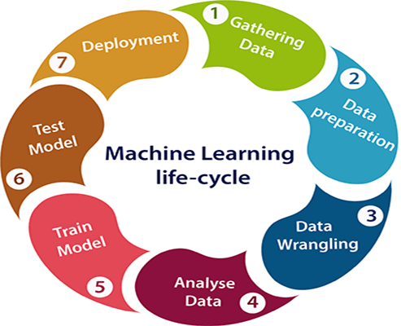

Fig 1: Machine Learning Life Cycle

1. *Data preparation*: After collecting the data, we need to prepare it for further steps. It is a step where we put our data into a suitable place and prepare it to use in our machine-learning training. In this step, we put all data together and then randomize the ordering of data. This step can be further divided into two processes: *Data exploration and Data pre-processing*.
2. *Data Wrangling*: Data wrangling is the process of cleaning and converting raw data into a usable format. It is the process of cleaning the data, selecting the variable to use, and transforming the data into a proper format to make it more suitable for analysis in the next step. It is one of the most important steps of the complete process. Cleaning of data is required to address the quality issues. The data we have collected don't need to be always for our use as some of the data may not be useful. In real-world applications, collected data may have various issues, including *missing values, duplicate data, invalid data, and noise*. It is mandatory to detect and remove the above issues because they can negatively affect the quality of the outcome.
3. *Data Analysis*: Now the cleaned and prepared data is passed on to the analysis step. This step involves *the Selection of analytical techniques, Building models, and Reviewing the result*. This step aims to build a machine learning model to analyze the data using various analytical techniques and review the outcome. It starts with determining the type of the problems, where we select the machine learning techniques such as *Classification, Regression, Cluster analysis, Association, etc.* then build the model using prepared data, and evaluate the model. Hence, in this step, we take the data and use machine learning algorithms to build the model.
4. *Train Model*: Now the next step is to train the model, in this step we train our model to improve its performance for a better outcome of the problem. We use datasets to train the model using various machine-learning algorithms. Training a model is required so that it can understand the various *patterns, rules, and features*.
5. *Test Model*: Once our machine learning model has been trained on a given dataset, then we test the model. In this step, we check for the accuracy of our model by providing a test dataset to it. Testing the model determines the percentage accuracy of the model as per the requirement of projection or problem.
6. *Deployment*: The last step of the machine learning life cycle is deployment, where we deploy the model in the real-world system. If the above-prepared model is producing an accurate result as per our requirement with acceptable speed, then we deploy the model in the real system. But before deploying the project, we will check whether it is improving its performance using available data or not.

The machine learning workflow is described in Fig 2:

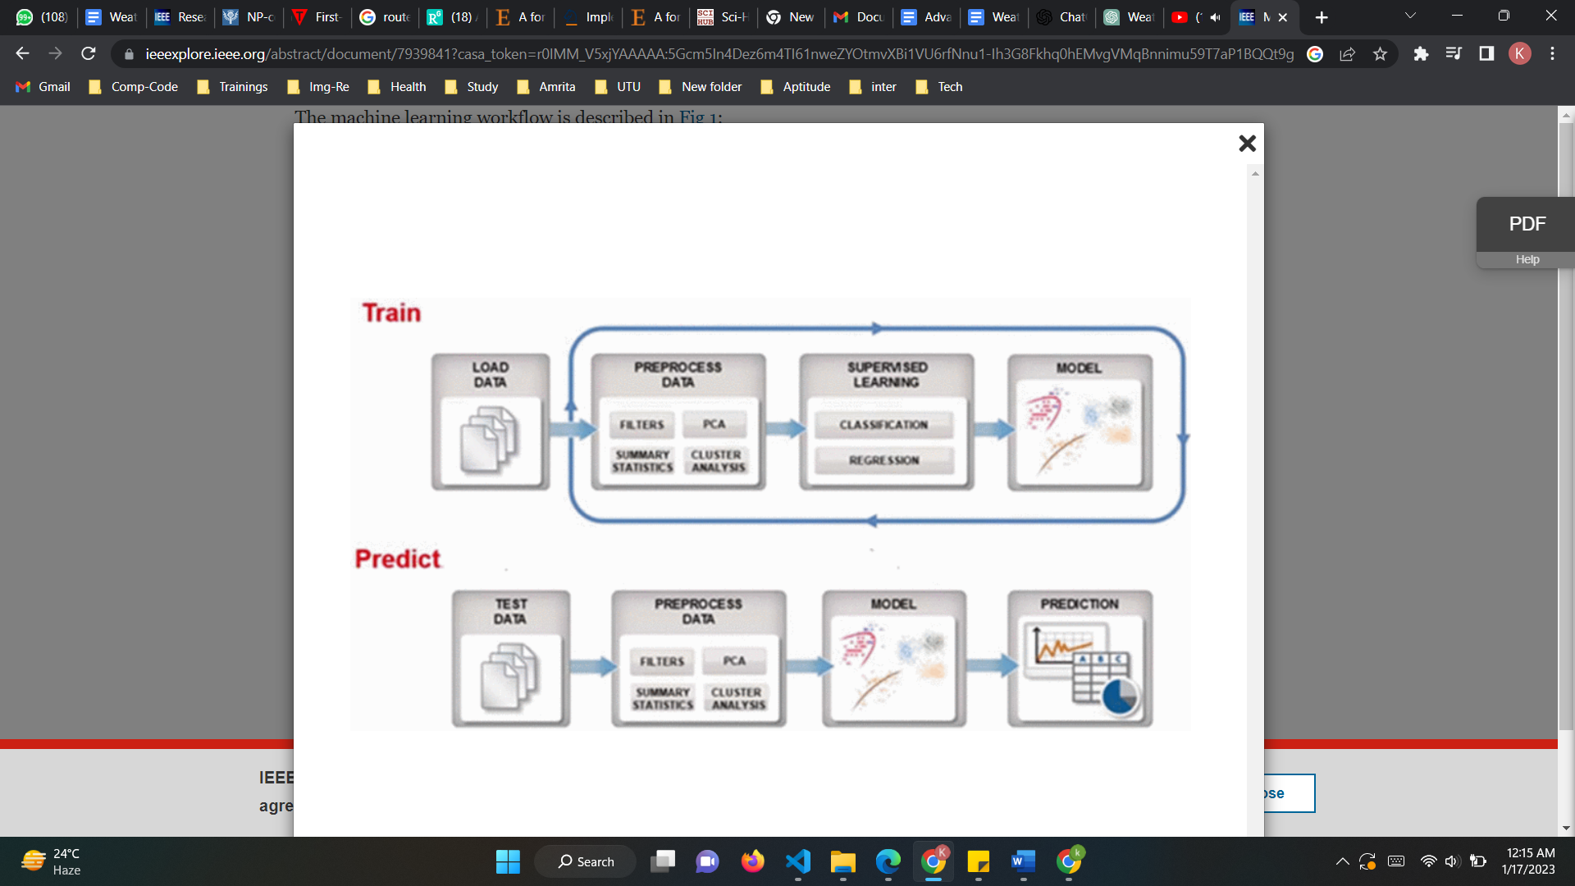

Fig 2: Machine Learning WorkFlow

Different methodologies used for the comparative study for the classifications are as follows:

## Logistic Regression

Logistic regression is one of the most popular machine learning algorithms under the supervised learning technique. It is used for predicting the categorical dependent variable using a given set of independent variables.

Logistic Regression predicts the output of a categorical dependent variable. Therefore the outcome must be a categorical or discrete value. It can be either Yes or No, 0 or 1, True or False but instead of giving the exact value as 0 and 1, it gives the probabilistic values which lie between 0 and 1.

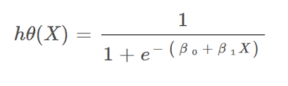

Logistic Regression is much similar to Linear Regression except that how they are used. Linear Regression is used for solving Regression problems, whereas Logistic regression is used for solving the classification problems.

It uses the concept of predictive modeling as regression; therefore, it is called logistic regression, but is used to classify samples; Therefore, it falls under the classification algorithm.

1. Decision Tree:

A decision tree is a supervised learning technique that can be used for both classification and regression problems, but mostly it is preferred for solving classification problems. It is a tree-structured classifier, where internal nodes represent the features of a dataset, branches represent the decision rules and each leaf node represents the outcome.

In a Decision tree, there are two nodes, which are the decision node and the leaf node. Decision nodes are used to make any decision and have multiple branches, whereas leaf nodes are the output of those decisions and do not contain any further branches. The decisions for the test are performed based on features of the given dataset.

It is a graphical representation for getting all the possible solutions to a decision based on given conditions. It is called a decision tree because similar to a tree, it starts with the root node, which expands on further branches and constructs a tree-like structure.

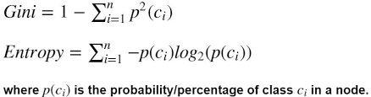

1. Random Forest:

Random forest is a Supervised Machine Learning Algorithm that is used widely in Classification and Regression problems. It builds decision trees on different samples and takes their majority vote for classification and average in case of regression. One of the most important features is that it can handle the data set containing continuous variables as in the case of regression and categorical variables as in the case of classification.It consists of many decision trees. The ‘forest’ generated by this algorithm is trained through bagging or bootstrap aggregating. Bagging is an ensemble meta-algorithm that improves the accuracy of machine learning algorithms.

This algorithm establishes the outcome based on the predictions of the decision trees. Increasing the number of trees increases the precision of the outcome. It performs better results for classification problems. It reduces the overfitting of datasets and increases precision.

1. ADABoost

AdaBoost stands for Adaptive Boosting. It is a statistical classification algorithm. It is an algorithm that forms a committee of weak classifiers. It boosts the performance of machine learning algorithms. It helps you form a committee of weak classifiers by combining them into a single strong classifier. It can be used to solve a wide range of problems. The main idea of the AdaBoost classifier is to increase the weight of the unclassified points and also decrease the weight of the classified points. In the case of the Adaboost classifier, the trees are not fully grown, and the trees are just one root and two leaves, called stumps.

1. XGBoost

XGBoost is a robust machine-learning algorithm that can help you understand your data and make better decisions. It is an implementation of gradient-boosting decision trees. It has been used by data scientists and researchers worldwide to optimize their machine-learning models.

The basic formula for XGBoost is an extension of the gradient boosting algorithm, which iteratively adds weak learners (decision trees) to the model.

At each iteration, XGBoost calculates the gradient of the loss function to the current predictions and fits a decision tree to the negative gradient. The decision tree is then added to the current ensemble of trees, and the predictions are updated.

The final predictions of XGBoost are then given by:

F(x) = Σ(f_i(x)) for i = 1 to N

where F(x) is the final prediction,

f_i(x) is the ith decision tree in the ensemble, and

N is the total number of trees in the ensemble.

XGBoost also uses a technique called regularization to prevent overfitting, which adds a penalty term to the loss function. The specific form of this regularization term depends on the type of regularization used (e.g. L1 or L2 regularization).

1. Support Vector Machine

Support Vector Machine (SVM) is a supervised machine learning algorithm that can be used for both classification and regression challenges. However, it is mostly used in classification problems. In the SVM algorithm, we plot each data item as a point in n-dimensional space (where n is a number of features) with the value of each feature being the value of a particular coordinate.

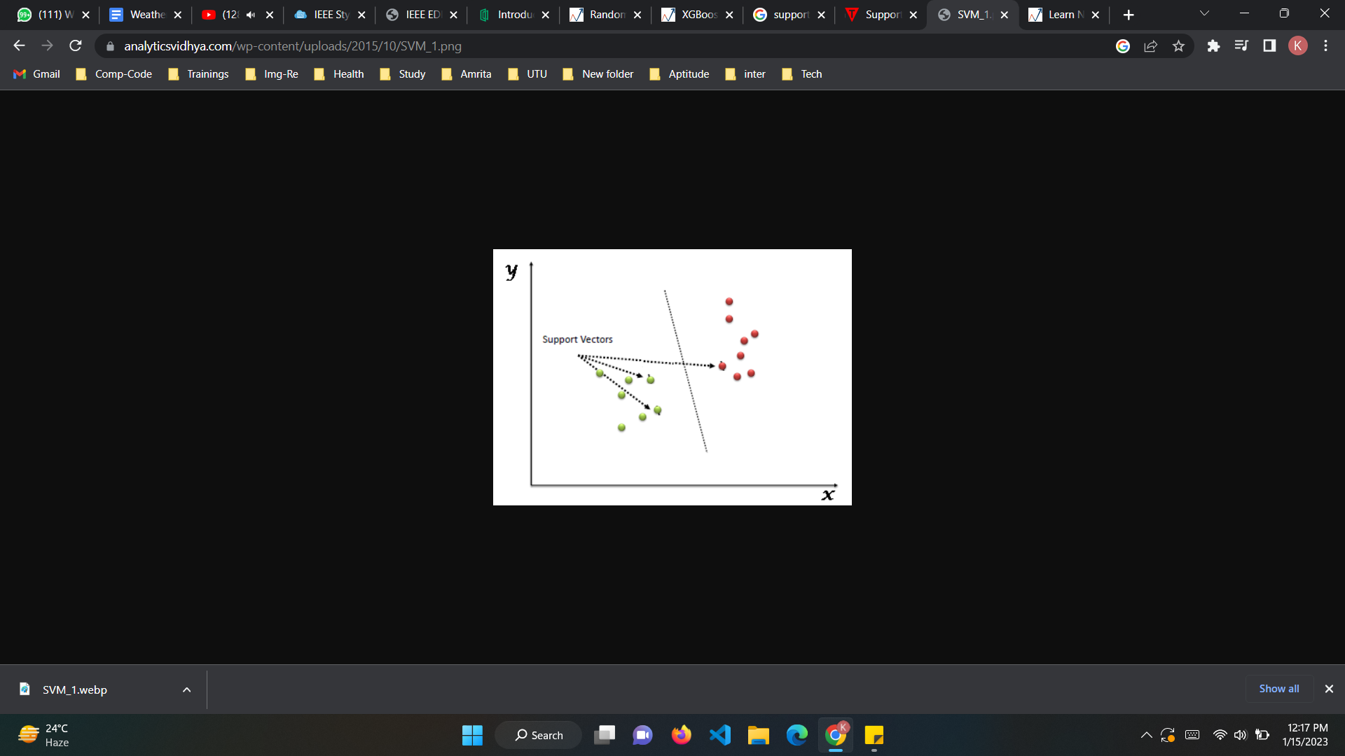

Fig:3: Support Vector Machines

Then, we perform classification by finding the hyper-plane that differentiates the two classes.

* *Linear Kernel*: f(X1, X2) = (a + X1^T * X2) ^ b ,X1 and X2 represent data.

### *Gaussian Radial Basis Function (RBF)*: f(X1, X2) = exp(-gamma * ||X1 - X2||^2), gamma specifies how much a single training point has on the other data points around it. ||X1 - X2|| is the dot product between your features.

* *Sigmoid Kernel:* f(X, y) = tanh(alpha * X^T * y + C), alpha is a weight vector and C is an offset value to account for some misclassification of data that can happen.

1. Naive Bayes

It is a classification technique based on Bayes’ Theorem with an assumption of independence among predictors. In simple terms, a Naive Bayes classifier assumes that the presence of a particular feature in a class is unrelated to the presence of any other feature. The naive Bayes model is easy to build and particularly useful for very large data sets. Along with simplicity, Naive Bayes is known to outperform even highly sophisticated classification methods.

Bayes's theorem provides a way of calculating posterior probability P(c|x) from P(c), P(x), and P(x|c). Look at the equation below:

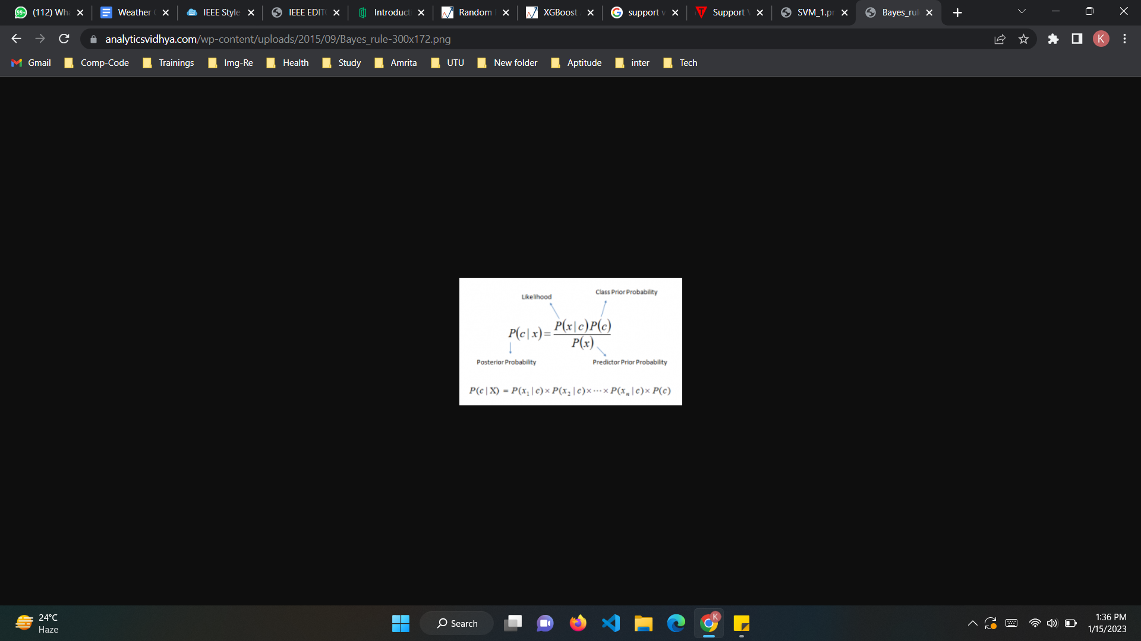

Fig: 4: Naive Bayes

1. KMeans

The K-means clustering algorithm computes centroids and repeats until the optimal centroid is found. It is presumptively known how many clusters there are. It is also known as the flat clustering algorithm. The number of clusters found from data by the method is denoted by the letter ‘K’ in K-means.

In this method, data points are assigned to clusters in such a way that the sum of the squared distances between the data points and the centroid is as small as possible. It is essential to note that reduced diversity within clusters leads to more identical data points within the same cluster.

1. KNN

K-Nearest Neighbors (KNN) is a supervised learning algorithm used for classification and regression problems. The basic idea behind the algorithm is to find the K training examples that are closest (most similar) to a given test example, and use the labels of these K examples to predict the label of the test example.

The KNN algorithm is simple and easy to implement but it is sensitive to the scale of the data and irrelevant features. Also, it can be computationally expensive if the number of training examples is large.

1. MLP

A Multi-Layer Perceptron (MLP) is a type of neural network that is composed of multiple layers of artificial neurons. The most common architecture of an MLP is composed of an input layer, one or more hidden layers, and an output layer.

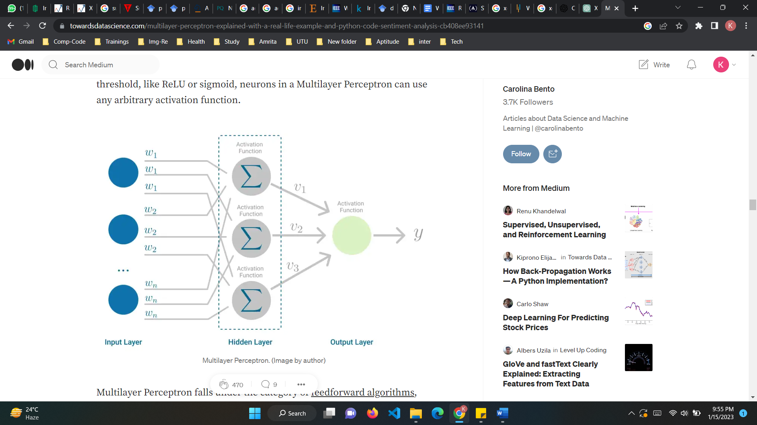

Fig 5: MultiLayer Perceptron

The input layer receives the input data, which is then processed by the hidden layers. Each neuron in a hidden layer receives input from all neurons in the previous layer and applies a non-linear transformation to it, such as the sigmoid or ReLU function.

The activation of softmax can be expressed mathematically, according to the following equation:

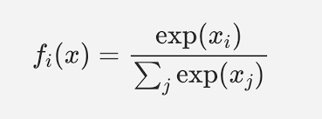

The output of the final hidden layer is passed to the output layer, which produces the final predictions.

MLP is commonly used for supervised learning tasks such as classification and regression, and it can also be used for unsupervised learning tasks such as dimensionality reduction and feature learning.

1. GMM

Gaussian Mixture Model or Mixture of the Gaussian model as it is a probability distribution. It is a universally used model for generative unsupervised learning or clustering. It is also called Expectation-Maximization Clustering or EM Clustering and is based on the optimization strategy. Gaussian Mixture models are used for representing Normally Distributed subpopulations within an overall population. The advantage of Mixture models is that they do not require which subpopulation a data point belongs to. It allows the model to learn the subpopulations automatically. This constitutes a form of unsupervised learning.

The probability distribution function of d-dimensions Gaussian Distribution is defined as



1. PCA

Principal Component Analysis or PCA is a widely used technique for the dimensionality reduction of a large data set. Reducing the number of components or features costs some accuracy and on the other hand, it makes the large data set simpler, and easy to explore, and visualize. Also, it reduces the computational complexity of the model which makes machine learning algorithms run faster.

In PCA, the goal is to find a new set of orthogonal axes, called principal components (PCs), which can be used to represent the data with the maximum amount of variance. Mathematically, this is achieved by finding the eigenvectors of the covariance matrix of the data, which correspond to the directions of maximum variance. The eigenvectors are then ordered by the corresponding eigenvalues, which indicate the amount of variance explained by each PC.

The PCA transformation can be represented by a matrix W, where each column is an eigenvector of the covariance matrix. The new data representation, Z, is then given by the matrix multiplication of X (the original data) and W:

Z = X * W

Where X is the data matrix with size (n x d), W is the PCA transformation matrix with size (d x k) and Z is the new data matrix with size (n x k), k is the number of principal components to keep.

PCA can be performed using the SVD(Singular Value Decomposition) of the data matrix X, which is computationally more efficient for large datasets and also applicable for sparse matrix

X = U * S * V^T

Where U and V are orthogonal matrices and S is a diagonal matrix with singular values on the diagonal.

In PCA, we select the k largest singular values and the corresponding columns of U as the new basis vectors.

1. Experiment and Analysis
2. *Preprocessing*: A dataset of 1500 images of the weather of five different classes: cloudy, rainy, shiny, sunset, and foggy with 32x32 dimensions and 3072 features was used to classify the images into different weather categories. The dataset was split into train and test data with a test size of 0.01. Different machine learning algorithms such as logistic regression, decision tree, random forest, ADA Boost, XGBoost, and SVM were used to classify the images. To fit the data into the model, the matrix of the images was flattened into an array. This means that the matrix representing each image, which is a 3-dimensional array of pixels, was transformed into a 1-dimensional array of pixels. This step is necessary as many machine learning models require the input data to be in a specific format, such as a 1-dimensional array or a matrix with a certain shape. By flattening the images, the data can be easily fed into the model without any reshaping or reshaping errors.



Fig 6: Some example images from our image database.

1. *Logistic Regression:* A level-2 heading must be in Italic, left-justified and numbered using an uppercase alphabetic letter followed by a period. For example, see heading “C. Section Headings” above.
2. *Decision Tree:* The decision tree algorithm has an overall accuracy of 47%. The performance of the model varies for different classes in the dataset. For class 'cloudy', the model has a precision of 0.33, recall of 0.33, and f1-score of 0.33. For class 'foggy', the model has a precision of 0.50, recall of 0.67, and f1-score of 0.57. For class 'rainy', the model has a precision of 0.33, recall of 0.33, and f1-score of 0.33. For class 'shine', the model has a precision of 0.50, recall of 0.67, and f1-score of 0.57. For class 'sunrise', the model has a precision of 1.00, recall of 0.33, and f1-score of 0.50.It can be observed that the model has relatively lower precision and recall for all classes except class 'sunrise' where it has high precision but relatively lower recall. 

Fig 7: Decision Tree

The overall accuracy of 47% suggests that the model is not performing well in terms of classifying the images correctly.It has performed very less accurately across all classes, with low precision, recall and f1-score.

1. *Random Forest:* The random forest algorithm gave an accuracy of 67%. The performance of the model varies for different classes in the dataset. For class 'cloudy', the model has a precision of 0.33, recall of 0.67, and f1-score of 0.44. For class 'foggy', the model has a precision of 1.00, recall of 0.67, and f1-score of 0.80. For class 'rainy', the model has a precision of 0.50, recall of 0.33, and f1-score of 0.40. For class 'shine', the model has a precision of 1.00, recall of 0.67, and f1-score of 0.80. For class 'sunrise', the model has a precision of 1.00, recall of 1.00, and f1-score of 1.00.

It can be observed that the model has relatively lower precision and recall for 'cloudy' and 'rainy' class while it has high precision and recall for 'foggy' and 'shine' class. The model has performed well for 'sunrise' class with precision and recall both 1.00 and f1-score of 1.00.

The Random Forest Classifier has performed well in some classes such as 'foggy' and 'shine' but poorly in 'cloudy' and 'rainy' class.



Fig 8: Random Forest

1. *ADABoost:* The ADABoost algorithm gave an accuracy of 53.33%. The performance of the model varies for different classes in the dataset. For class 'cloudy', the model has a precision of 0.33, recall of 0.33, and f1-score of 0.33. For class 'foggy', the model has a precision of 0.40, recall of 0.67, and f1-score of 0.50. For class 'rainy', the model has a precision of 0.33, recall of 0.33, and f1-score of 0.33. For class 'shine', the model has a precision of 1.00, recall of 0.67, and f1-score of 0.80. For class 'sunrise', the model has a precision of 1.00, recall of 0.67, and f1-score of 0.80.It can be observed that the model has relatively lower precision and recall for 'cloudy','foggy','rainy' class while it has high precision but relatively lower recall for 'shine' and 'sunrise' class. ADA Boost Classifier has performed poorly across all classes, with low precision, recall and f1-score. The overall accuracy of 53% suggests that the model is not performing well in terms of classifying the images correctly.



Fig 9: ADA Boost

1. *XGBoost:* The XGBoost algorithm gave an accuracy of 73.33%. The performance of the model suggests that for class 'cloudy', the model has a precision of 0.50, recall of 0.67, and f1-score of 0.57. For class 'foggy', the model has a precision of 1.00, recall of 1.00, and f1-score of 1.00. For class 'rainy', the model has a precision of 0.50, recall of 0.33, and f1-score of 0.40. For class 'shine', the model has a precision of 1.00, recall of 0.67, and f1-score of 0.80. For class 'sunrise', the model has a precision of 0.75, recall of 1.00, and f1-score of 0.86.



Fig 10: XGBoost - Model Output

So, XGBoost Classifier has performed well in some classes such as 'foggy' and 'shine' but poorly in 'cloudy' and 'rainy' classes. The overall accuracy of 73% suggests that the model is performing reasonably well in terms of classifying the images correctly.

1. *SVM:* Four different hyperparameters (linear, poly, rbf, and sigmoid) were used for image classification. Linear SVM gave an accuracy of 66.67%, poly SVM gave 46.67% accuracy, SVM-rbf gave 66.67% and sigmoid gave 66.67% accuracy. Hyperparameter Tuning (GridSearchCV) was used to select the best hyperparameters (gamma = 'scale' and 'kernel' ='poly') which gave the best accuracy of 80%.

Performance of this model shows that for class 'cloudy', the model has a precision of 0.67, recall of 0.67, and f1-score of 0.67. For class 'foggy', the model has a precision of 0.75, recall of 1.00, and f1-score of 0.86. For class 'rainy', the model has a precision of 0.50, recall of 0.33, and f1-score of 0.40. For class 'shine', the model has a precision of 1.00, recall of 1.00, and f1-score of 1.00. For class 'sunrise', the model has a precision of 1.00, recall of 1.00, and f1-score of 1.00. It can be observed that the model has relatively lower precision and recall for 'cloudy' and 'rainy' class while it has high precision, recall and f1-score for 'foggy', 'shine' and 'sunrise' class.



Fig 11: Output for SVM Model

SVM Classifier has performed well in some classes such as 'foggy', 'shine' and 'sunrise' but poorly in 'cloudy' and 'rainy' class. The overall accuracy of 80% suggests that the model is performing well in correctly classifying the images.

1. *Naive Bayes:* Classification report of Naive Bayes classifier says that the overall accuracy of the model is 73%. The performance of the model varies for different classes in the dataset. For class 'cloudy', the model has a precision of 0.67, recall of 0.67, and f1-score of 0.67. For class 'foggy', the model has a precision of 0.67, recall of 0.67, and f1-score of 0.67. For class 'rainy', the model has a precision of 0.50, recall of 0.33, and f1-score of 0.40. For class 'shine', the model has a precision of 1.00, recall of 1.00, and f1-score of 1.00. For class 'sunrise', the model has a precision of 0.75, recall of 1.00, and f1-score of 0.86.It can be observed that the model has relatively lower precision and recall for 'rainy' class while it has high precision, recall and f1-score for 'cloudy', 'foggy' and 'shine' class and high recall and f1-score for 'sunrise' class. 

Fig 12: Output for Naive Bayes Model

It has performed well in some classes such as 'cloudy', 'foggy' and 'shine' but poorly in 'rainy' class. The overall accuracy of 73% suggests that the model is performing reasonably well in terms of classifying the images correctly but still has room for improvement.

1. *KNN:* Classification report for a K-Nearest Neighbors classifier model used for weather image classification gives the overall accuracy of 73%. The performance of the model varies for different classes in the dataset. For class 'cloudy', the model has a precision of 1.00, recall of 0.67, and f1-score of 0.80. For class 'foggy', the model has a precision of 0.60, recall of 1.00, and f1-score of 0.75. For class 'rainy', the model has a precision of 0.50, recall of 0.33, and f1-score of 0.40. For class 'shine', the model has a precision of 0.67, recall of 0.67, and f1-score of 0.67. For class 'sunrise', the model has a precision of 1.00, recall of 1.00, and f1-score of 1.00. It can be observed that the model has relatively lower precision and recall for 'rainy' class while it has high precision, recall and f1-score for 'cloudy' and 'foggy' class and high recall and f1-score for 'sunrise' class. K-Nearest Neighbors Classifier has performed well in some classes such as 'cloudy' and 'foggy' but poorly in 'rainy' class. The overall accuracy of 73% suggests that the model is performing reasonably well in terms of classifying the images correctly but still has scope for improvement.



Fig 13: Output for KNN Model

1. *KMeans:* Classification report for a K-Nearest Neighbors classifier model used for weather image classification gives the overall accuracy of 60%. For class 'cloudy', the model has a precision of 0.40, recall of 0.67, and f1-score of 0.50. For class 'foggy', the model has a precision of 0.50, recall of 0.67, and f1-score of 0.57. For class 'rainy', the model has a precision of 0.00, recall of 0.00, and f1-score of 0.00. For class 'shine', the model has a precision of 0.67, recall of 0.67, and f1-score of 0.67. For class 'sunrise', the model has a precision of 1.00, recall of 1.00, and f1-score of 1.00.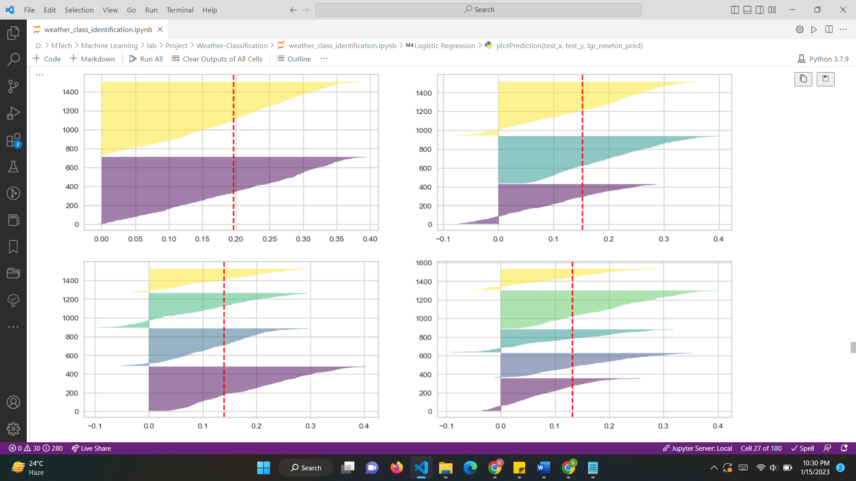

Fig 14: Silhouette Plot for KMeans

It can be observed that the model has relatively lower precision and recall for 'rainy' class while it has high precision, recall and f1-score for 'sunrise' class and lower precision, recall and f1-score for 'cloudy' and 'foggy' class. K-Means Clustering model has performed average across all classes in the dataset, especially in class 'rainy' where it has no precision and recall. The overall accuracy of 60% suggests that the model is not performing well in terms of classifying the images correctly and has a lot of room for improvement.



Fig 15: Output for KMeansModel

1. *MLP:* The classification report shows that the MLP model has an overall accuracy of 83%. However, the performance of the model varies for different classes in the dataset. For class 0, the model has a precision of 0.60, a recall of 1.00, and an f1-score of 0.75. For class 1, the model has a precision of 1.00, a recall of 0.67, and an f1-score of 0.80. For class 2, the model has a precision of 1.00, a recall of 0.67, and an f1-score of 0.80. For class 3, the model has a precision of 1.00, recall of 1.00, and f1-score of 1.00.



Fig 16: Output for MLP Model

It can be observed that the model has high precision and f1-score for all classes except class 1. Also, the model has high recall for class 0, but relatively lower recall for class 1 and 2. The overall accuracy of 83% suggests that the model is performing well in terms of classifying the images correctly.

1. *PCA:* Principal Component Analysis (PCA) is used for feature selection in image classification. PCA is a technique used to reduce the dimensionality of a dataset while retaining as much information as possible. In this case, the dataset is an image dataset with 3072 features and the goal is to identify which features are strongly correlated and use a smaller number of features for image classification.Different numbers of components are used for feature extraction, specifically 5, 10, 15, 30 and 50. By using different numbers of components, the model can identify which combination of features is most informative for the classification task. By using PCA to reduce the number of features, the model can avoid the curse of dimensionality and improve its performance.

Figure 17-23 shows the variation with different components in PCA and corresponding silhoutte plots.

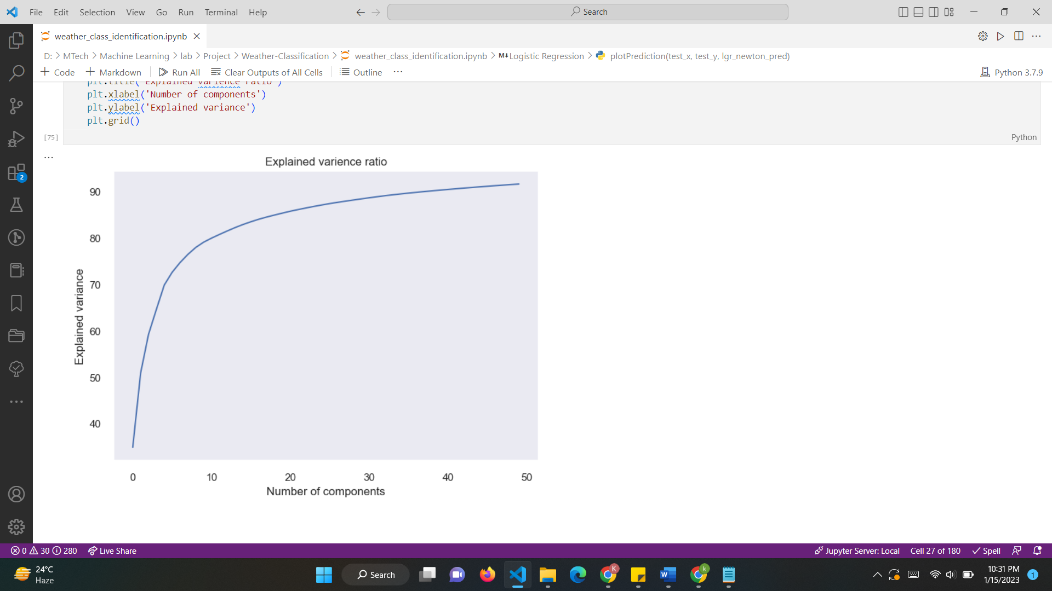

Fig 17: PCA

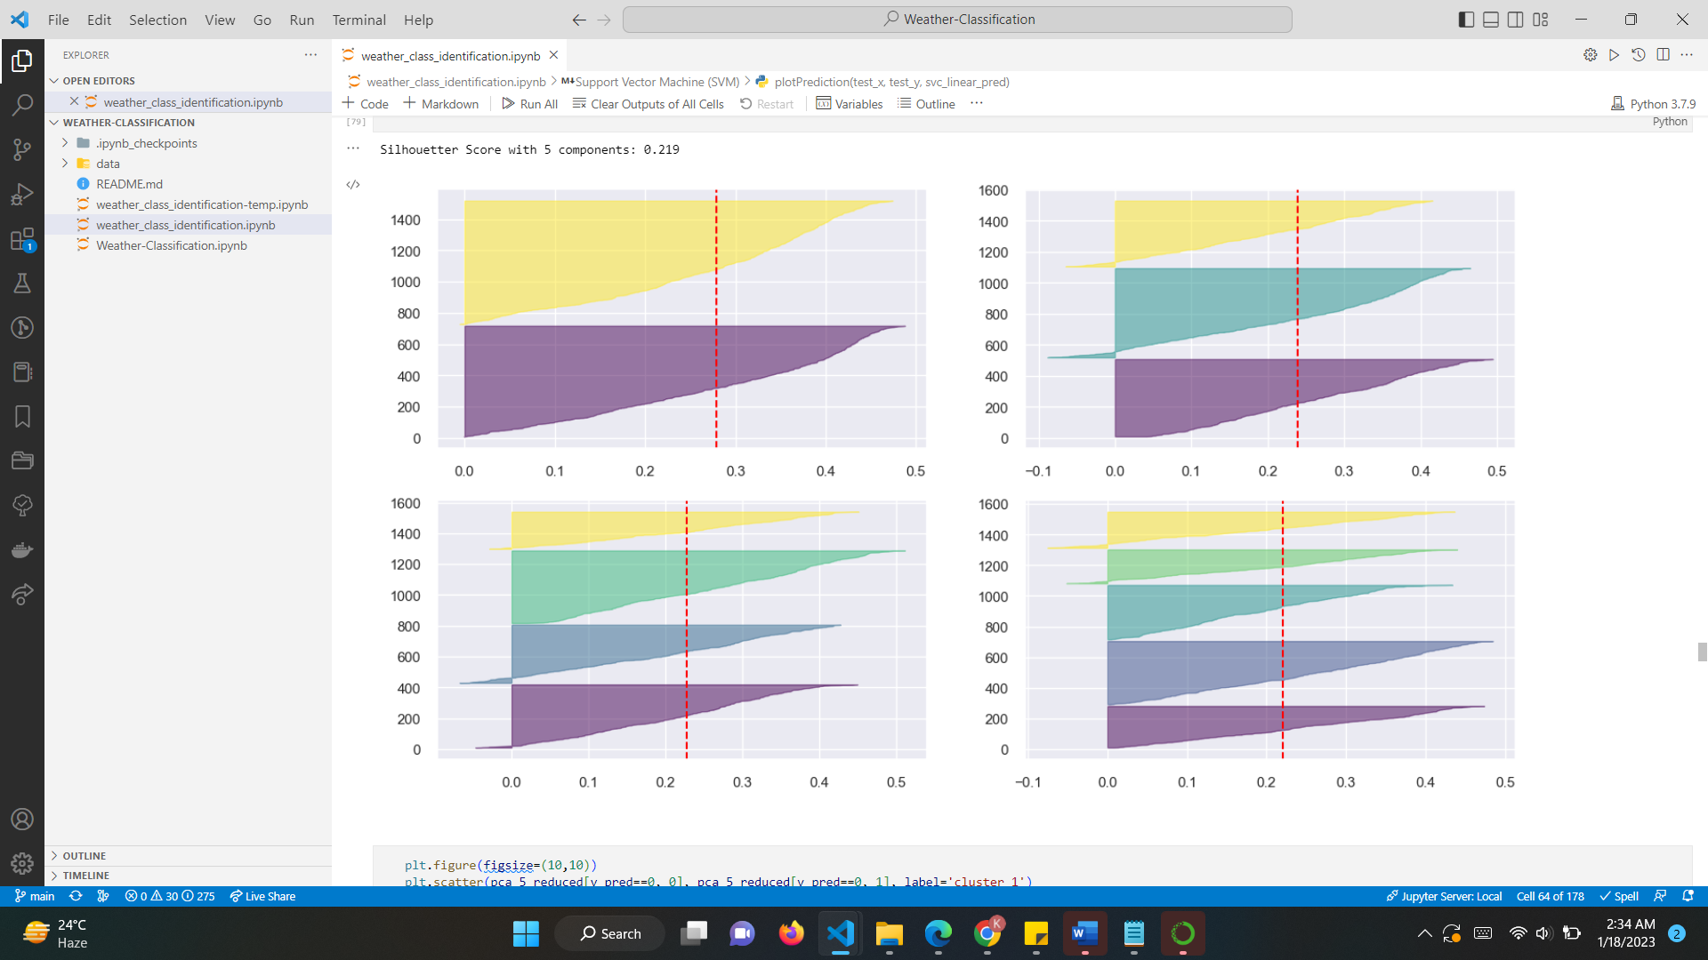

Fig 18: Silhouette plot for Clusters with 5 Components

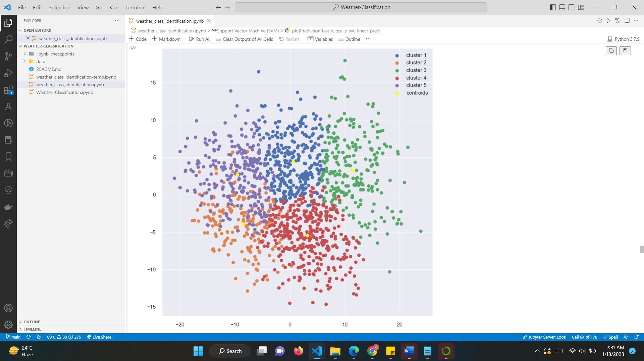

Fig 19: Clustering with 5 components

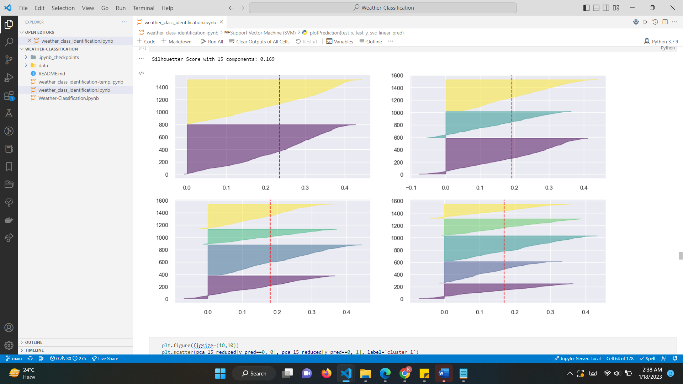

Fig 20: Silhouette plot for Clusters with 15 Components

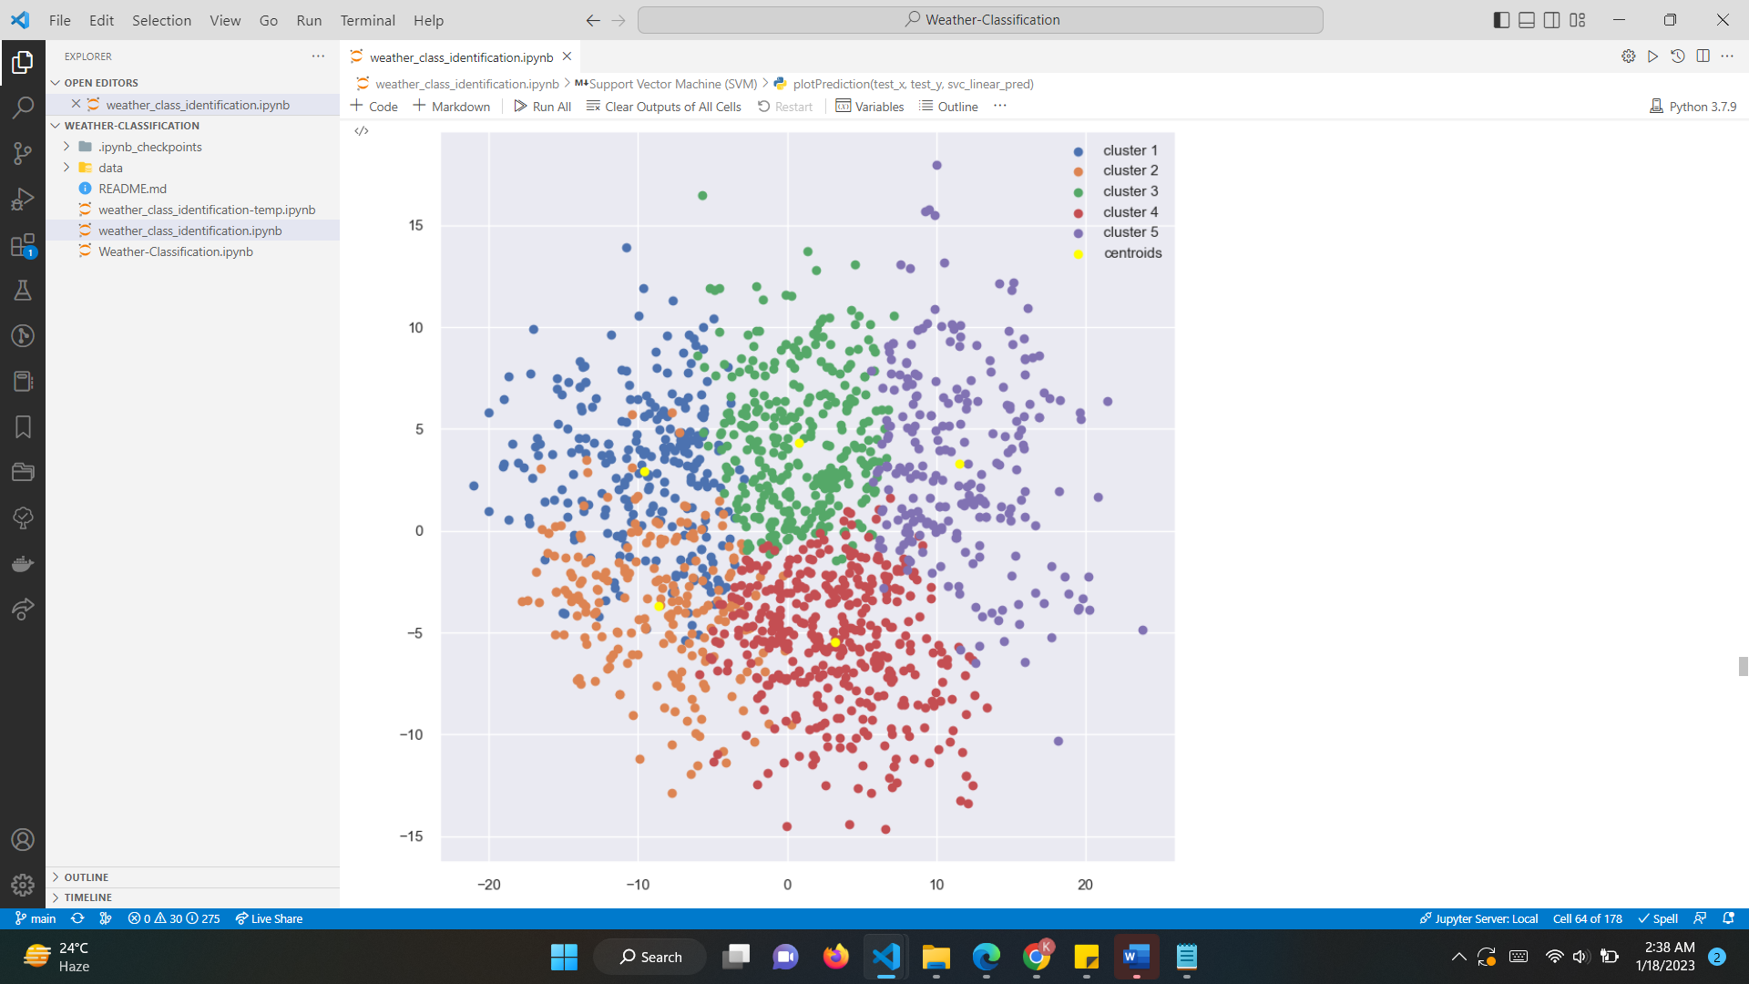

Fig 21: Clustering with 15 components



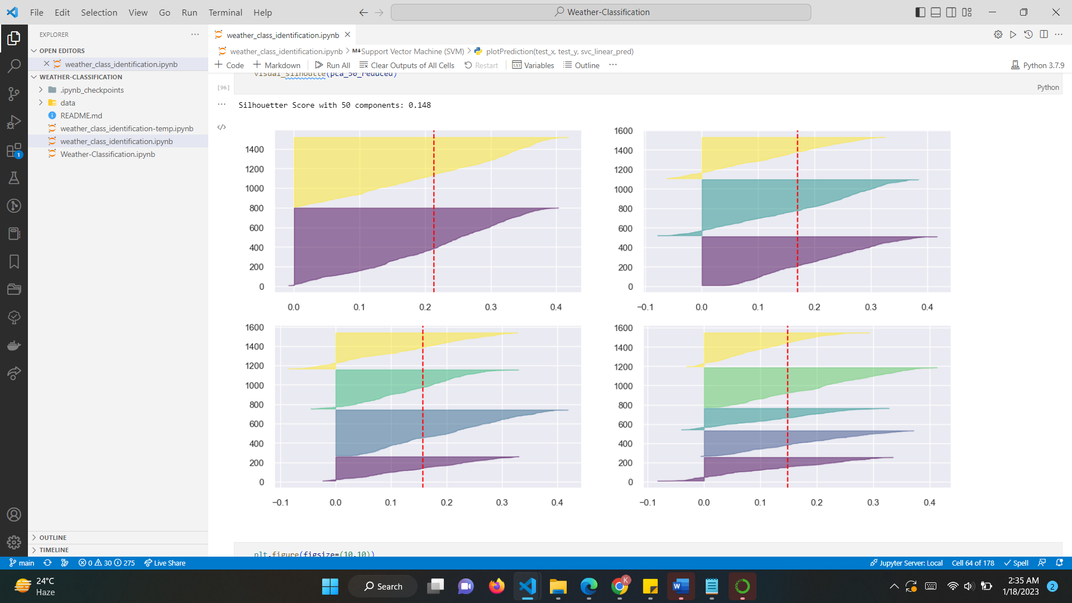

Fig 22: Silhouette plot for Clusters with 50 Components

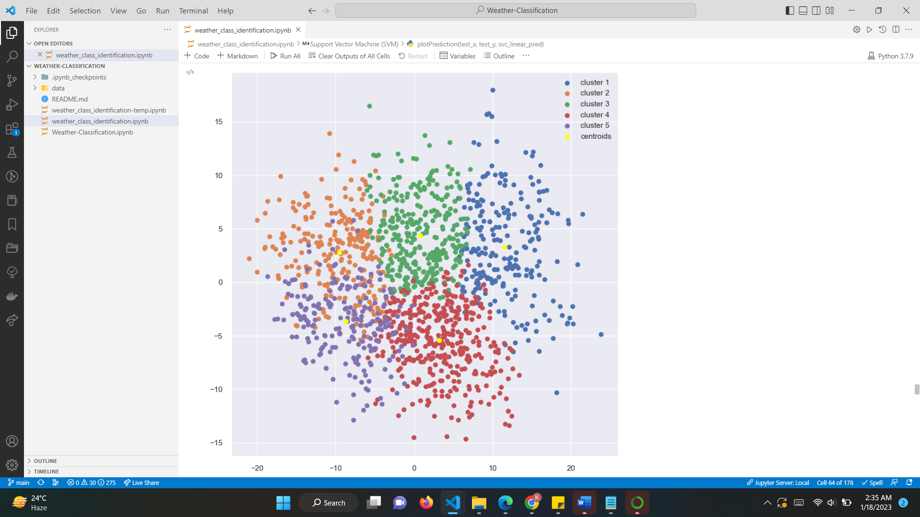

Fig 23: Clustering with 50 components

1. Gaussian Mixture Model (GMM):

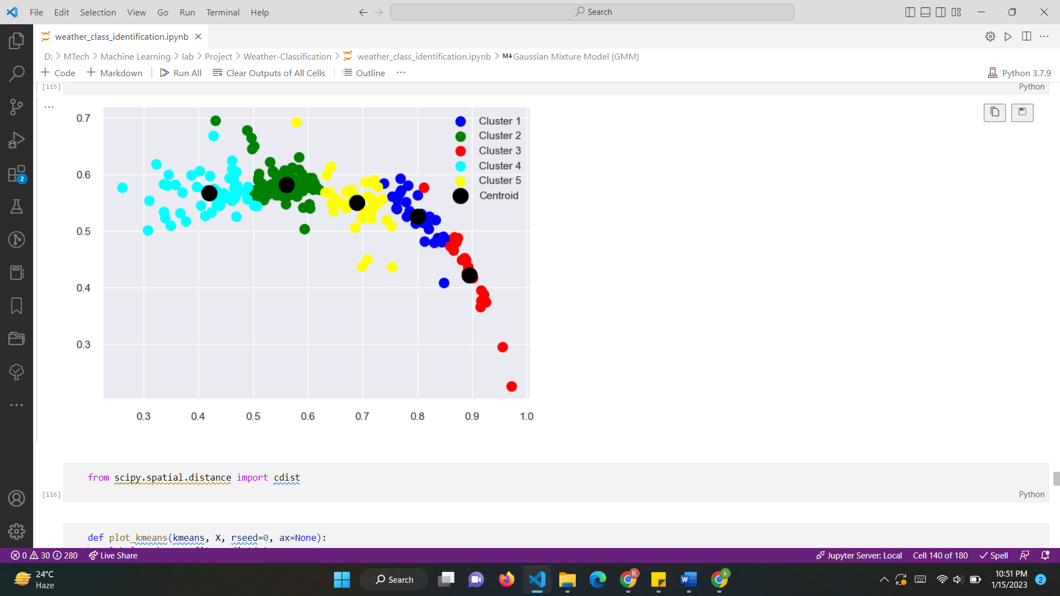

Fig 24: GMM

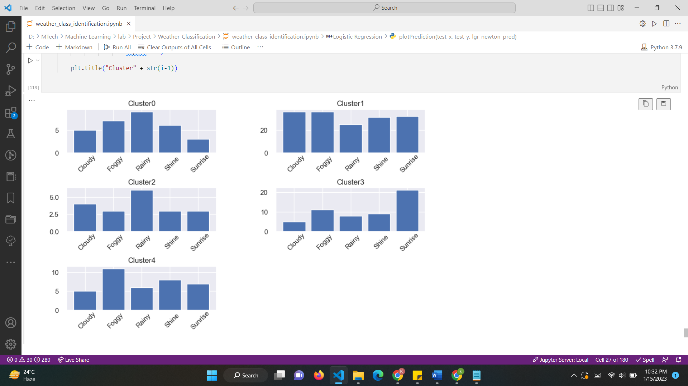



Fig 25: Bar Plot for K Clusters

Below figure shows the BIC(Bayesian Information Criterion) curve. This criterion gives us an estimation on how good the GMM is in terms of predicting the data we actually have. The lower is the BIC, the better is the model to actually predict the data we have, and by extension, the true, unknown, distribution. In order to avoid overfitting, this technique penalizes models with a big number of clusters.

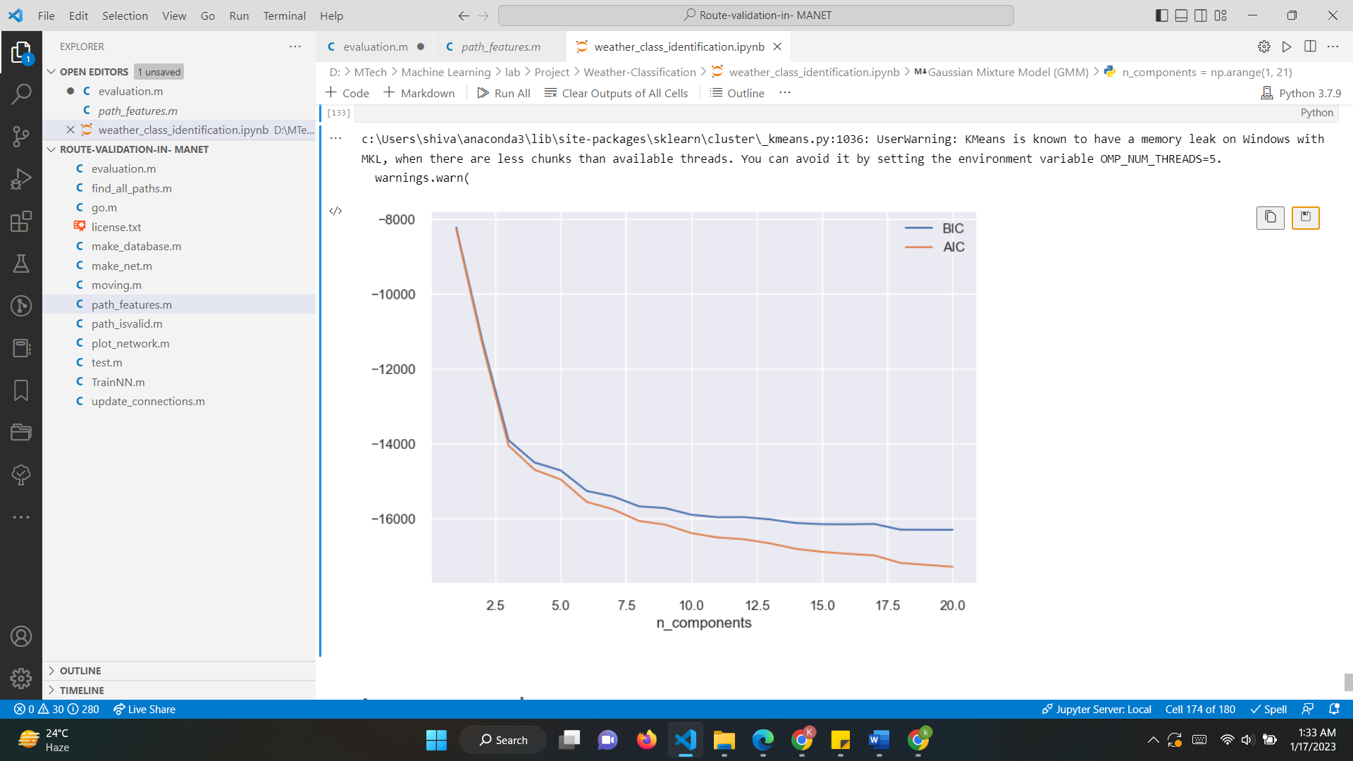

Fig 26: BIC,AIC curve for GMM

1. CONCLUSION

In this project various machine learning models are implemented such as Logistic Regression, Decision Tree, Random Forest, AdaBoost, XGBoost, SVM, Naive Bayes, K-Nearest Neighbor, K-Means, and MLP for weather classification. For the analysis, we did a comparison between training & testing accuracy which we can see below and from that, we conclude each model bias and variance and what we can do to make a perfect model.

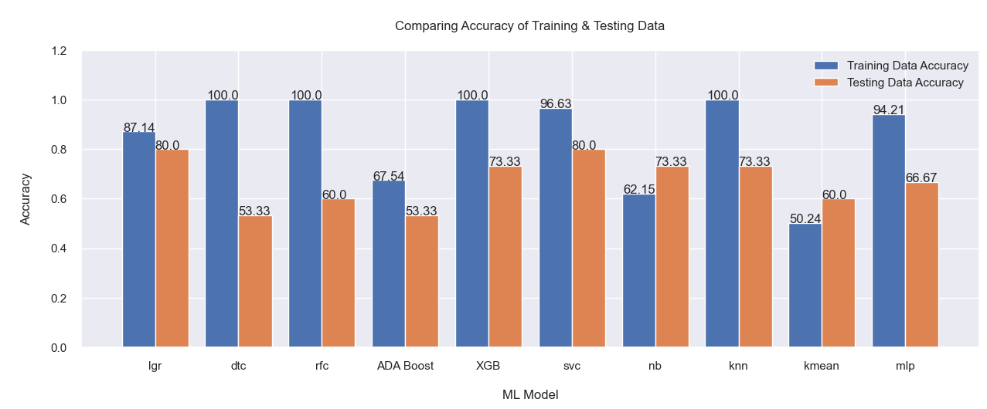

Fig 27: Accuracy Graph (Accuracy v/s ML Model)

So now, from the above information, We concluded each and every model below:

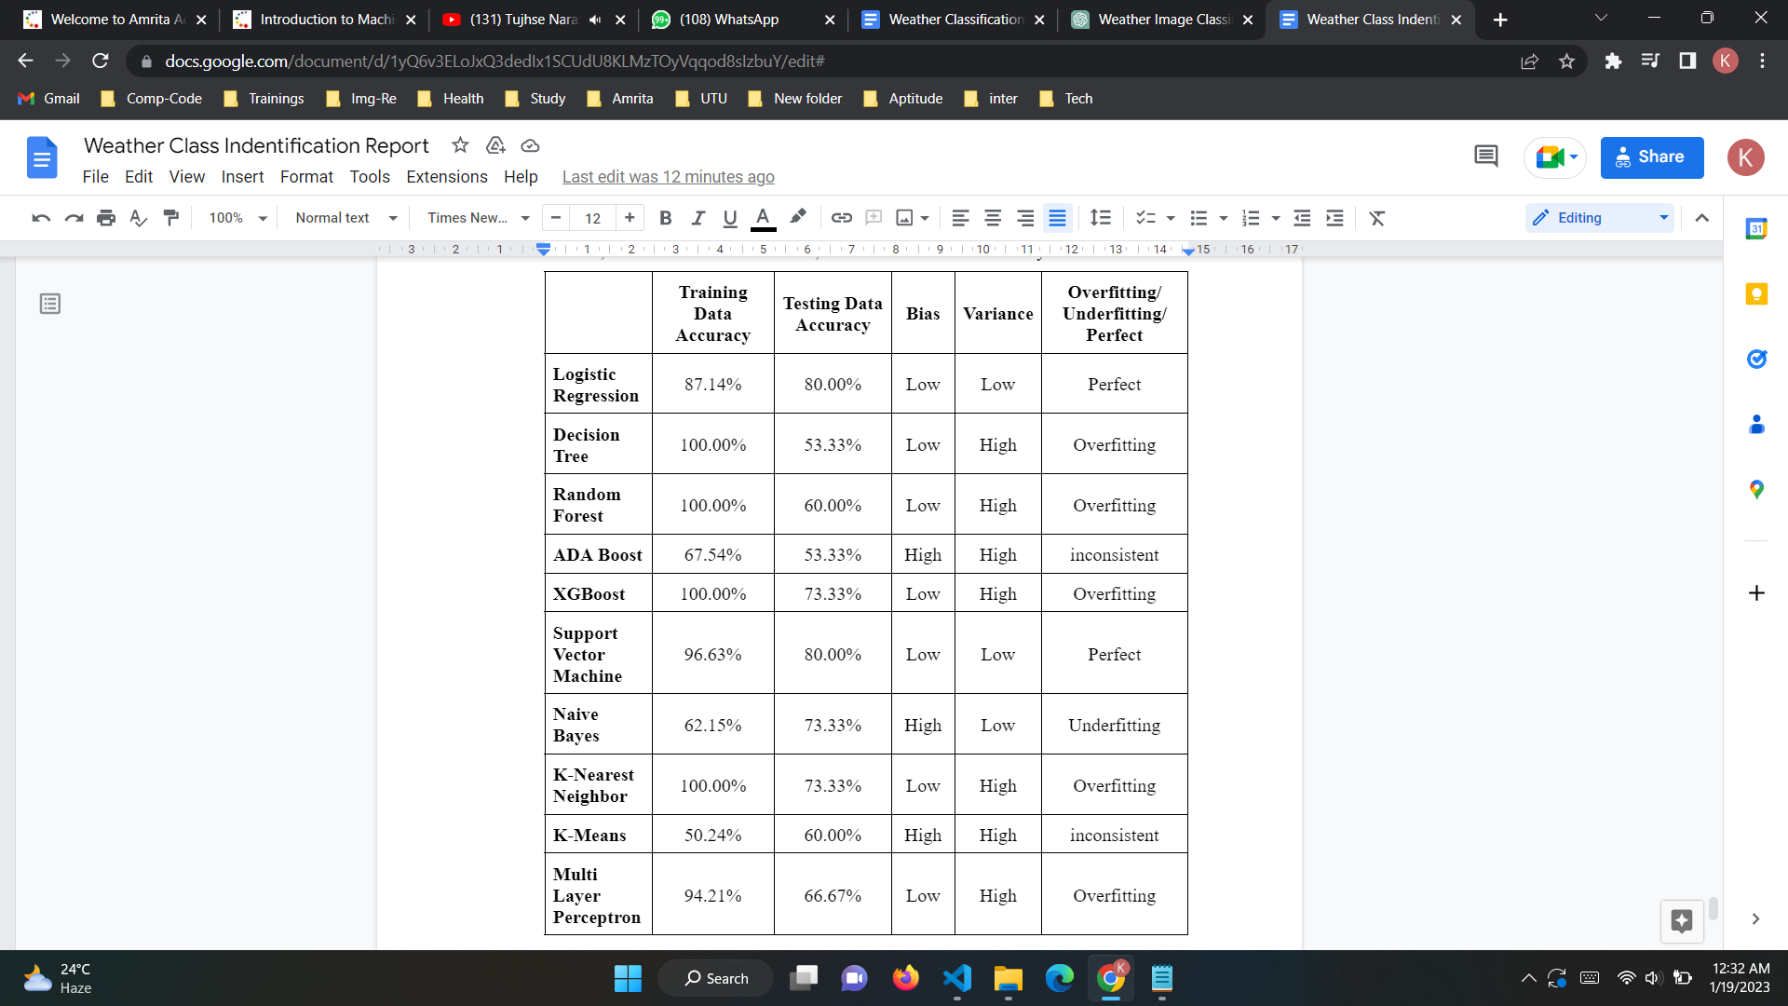

Table 1: Comparative study for all Models

*Bias*: The overall error associated with “Training Data” is termed as bias. When the training data error increase, or training data accuracy decrease, it is referred to as *high bias,* and when the training data error decreases or training data accuracy increases, it is referred to as *low bias*.

*Variance*: The overall error associated with “Testing Data” is termed as a variance. When the errors associated with testing data increase, it is referred to as *high variance,* and when the training data error decreases or training data accuracy increases, it is referred to as *low variance*.

From the above table analysis based on our implementation, we can conclude that outcomes and prediction of logistic regression and support vector Machine are resulting in better accuracy than other models.

References

1. [Sehla](https://ieeexplore.ieee.org/author/37086159264) Loussaief; Afef [Abdelkrim](https://ieeexplore.ieee.org/author/37640746400),*Machine learning framework for image classification*
2. Mohamed Elhoseiny, Sheng Huang, Ahmed Elgammal,*Weather Classification with Deep Convolutional Network,2015*
3. <https://www.kaggle.com/datasets/vijaygiitk/multiclass-weather-dataset>
4. <https://www.kaggle.com/code/sanjuthreddy/20bd1a6647-weather-classification>
5. <https://www.kaggle.com/code/gulsahdemiryurek/image-classification-with-logistic-regression>
6. <https://www.kaggle.com/code/mukthalavinaykumar/21bd5a6706weatherclassification>
7. <https://www.analyticsvidhya.com/blog/2022/01/image-classification-using-machine-learning/>
8. <https://towardsdatascience.com/k-means-dbscan-gmm-agglomerative-clustering-mastering-the-popular-models-in-a-segmentation-c891a3818e29>
9. <https://towardsdatascience.com/k-means-and-pca-for-image-clustering-a-visual-analysis-8e10d4abba40>
10. <https://towardsdatascience.com/multiclass-classification-algorithm-from-scratch-with-a-project-in-python-step-by-step-guide-485a83c79992>